Assignment

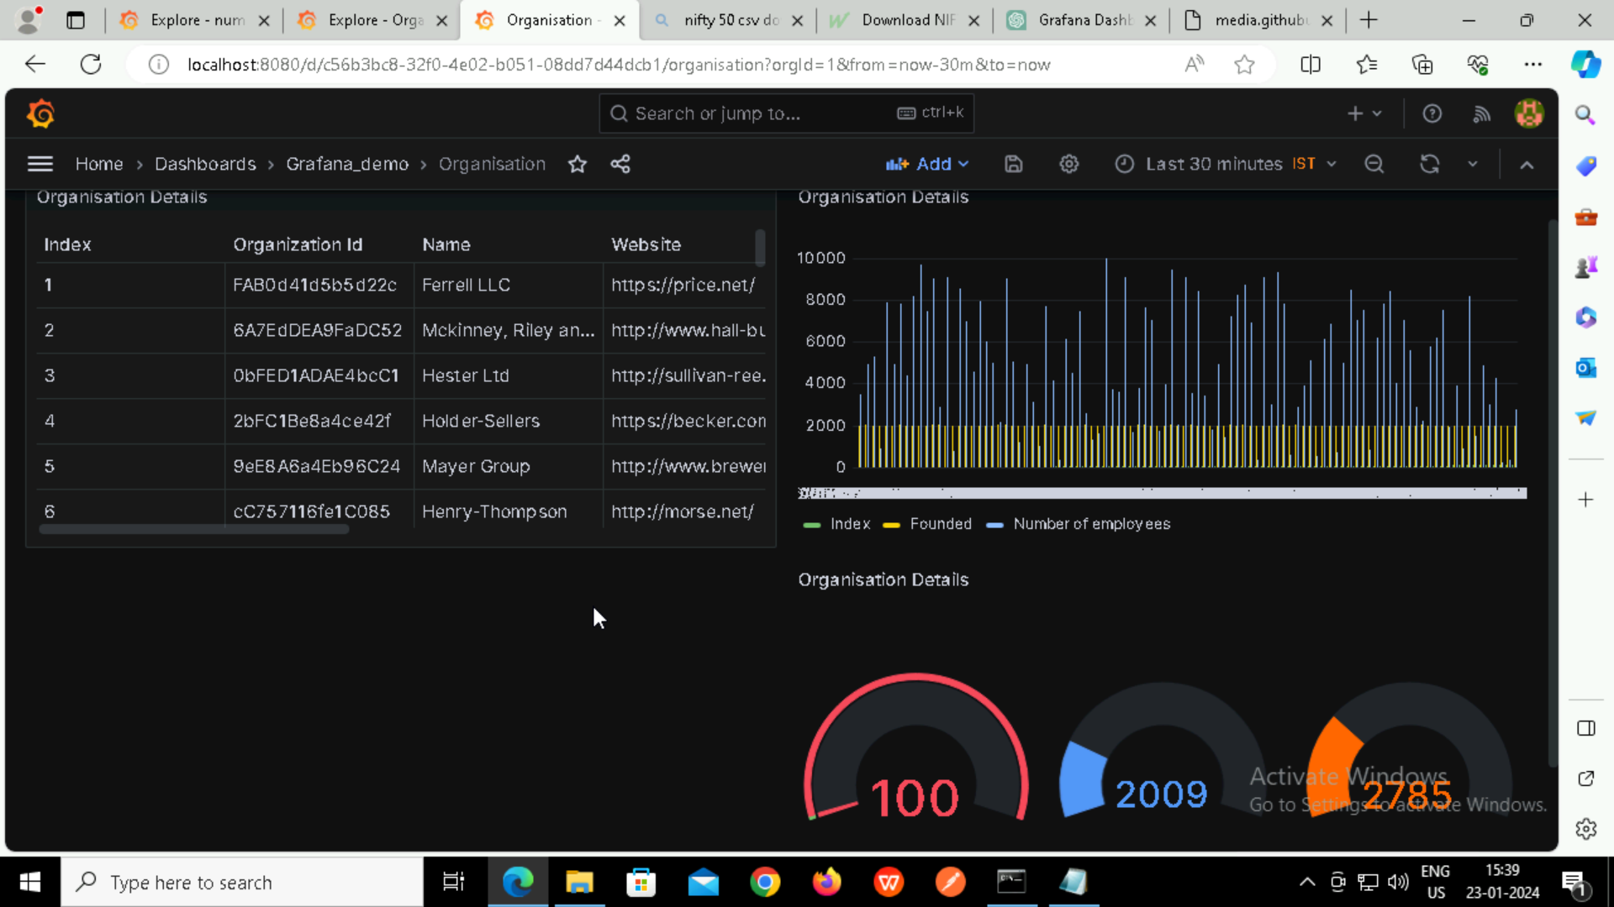

**Panel 1: Table**

Showcase raw data with various columns like organization ID, name, location, and

**Panel 2: Bar Chart**

Compare the number of employees in different organizations using a bar chart. Each bar represents an organization, and the height indicates the number of employees.

**Panel 3: Gauge**

Use a gauge to represent a single metric, such as the average number of employees across all organizations. The gauge can show whether the metric is below, within, or above a target range.

**Challenges and Solutions:**

Challenge 1: Data Formatting

Issue: The CSV data might not be in the ideal format for visualization.

Solution: Use Grafana's data transformation features to modify and format the data as needed. For example, you can aggregate or filter data within Grafana.

Challenge 2: Interactivity Implementation

Issue: Implementing interactivity features, such as a time range selector, might be challenging.

Solution: Refer to Grafana documentation for time range selector configuration. Ensure that your data has a timestamp field for time-based filtering.